ROOK ENDINGS

By the term “Rook Endings” are understood positions in which both sides have one or both Rooks and there are Pawns on the board.

It is not an easy task to deal with this class of ending from the point of view of the student. In fact, Rook endings form one of the most important branches of end-game theory, as they very frequently occur in actual play. Their correct treatment, however, is usually very difficult, so much so that even the greatest masters are liable to errors. For our purposes, it must be sufficient to provide the student with the most important general principals, and to illustrate them by typical examples.

In endings of Rook and Pawn against the Rook alone, a win is only possible if the opponent’s King is cut off from the queening square.
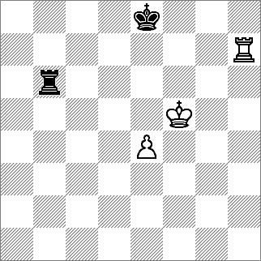
Philidor's Position
Black draws without difficulty by following the rule that the Rook shall not leave the sixth rank until the Pawn has entered it.

1.e5 Ra6
2.Rb7 Rc6
3.e6 Rc1
4.Kf6 Rf1+
And from now on the Rook either gives perpetual check or attack the pawn when it is unprotected by the Rook.

Even when the opposing King is cut off from the queening square the game cannot always be won. A draw frequently occurs in the case of a Rook Pawn, as shown by the following position:

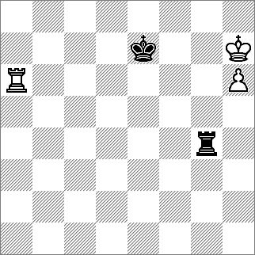

1.Rg6 Rf4
2.Kg7 Rf7+
3.Kh8 Rf8+
4.Rg8 Rf6
5.h7 Kf7
0r
1.Rg6 Rf4
2.Rg8 Kf7
3.Rg7 Kf8
4.Rg6 Rg4+
5.Rf6 Rxg7

The student must play through these variations and look at other possibilities.

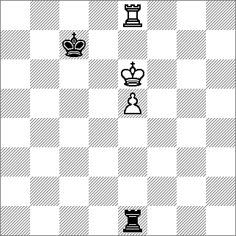

Lucena’s Position (1)
White, to play, wins

1.Kf7 Kd7 2.e6+ Kc7 [2...Kd6 3.Rd8+] 3.Ke7 [3.e7?] 3...Re2 4.Rf8 Re1 5.Rf2 Re3 6.Rc2+ Rb7 7.Rd7 Rd3+ 8.Ke8 Rd1 9.e7 Re1
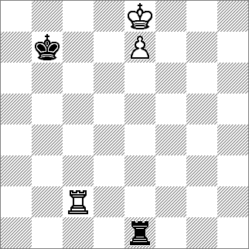
Lucena’s Position (2)

White is now apparently confronted by an insuperable difficulty: if he moves his King from e8 he is in perpetual check, and if the White Rook leaves the Bishop’s(c) file, then Kc7 follows, and the White King is blockaded. There is, however, one winning manoeuvre to which we which to draw the student’s attention.

10.Rc4 The reason why the R must be played only to the fourth rank will soon become apparent. 10...Rf2 11.Kd7 Rd2+ 12.Ke6 Re2+ 13.Kd6 Rd2+ 14.Ke5 Now the Rook can interpose and that is the reason why it had to be played to the fourth rank. Please study these positions in your own time and make notes on any queries that you might have. Ask coaches to explain.

In the following position, White’s progress to a win is very interesting:

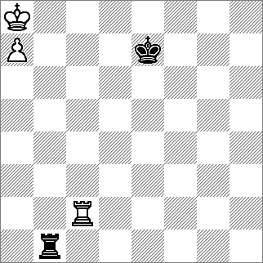
1.Rc8!
[14.Rc7+? Kd6 15.Rb7 Rh1] 1... Kd6
[14...Kd7 15.Rb8 Rh1 16.Kb7 Rb1+ 17.Ka6 Ra1+ 18.Kb5 Rb1+ 19.Kc4 Rc1+ 20.¢d4 Rd1+ 21.¢c3]
2.Rb8 Ra1
3.Kb7 Rb1+
4.Kc8 Rc1+
5.Kd8 Rh1
6.Rb6+ Kc5
7.Rc6+! Kb5
8.Rc8 Rh8+
9.Kc7 Rh7+
10.Kb8

Rook and two united Pawns generally win against the Rook alone. The player with the Pawns must, however, avoid certain exceptional positions with Knight and Rook Pawns, such as the following:
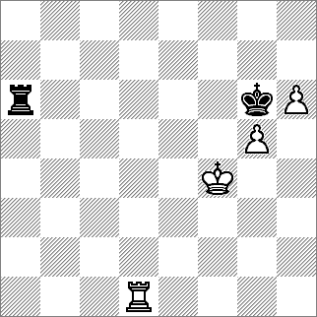

It is useless for White to play Kg4, as the black Rook never leaves its present rank, and to 1.Rd5; Ra4+ would follow, and the White King is cut off.

In this position White, to play, wins by sacrificing the Rook’s Pawn.
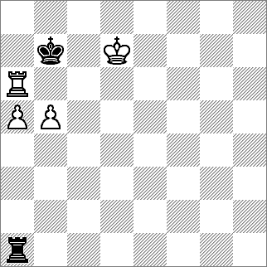
1.Rb6+ Ka7 2.Kc7 Rxa5 3.Rb7+ Ka8 4.Rb8+ Ka7 5.b6+ Ka6 6.Ra8+

In endings in which both players have Rook and Pawns, it makes a difference whether the Pawns are only on one or on both sides of the board. In the first case, if the Kings are near their Pawns and the forces equal, a draw is almost certain. Moreover, the advantage of one Pawn is only decisive in exceptional cases. The player who has the advantage n material and is therefore trying to win should avoid the exchange of Pawns, as his winning chances are thereby lessened. Four Pawns against three have a slightly better chance than three against two.

In cases where there are Pawns on both sides of the board and the forces are equal, everything depends on the position. A case frequently occurring in practice is that in which on one side there is an equal number of Pawns, on the other while one player has a passed Pawn. In such positions the general rule is that the Pawn is better placed behind and not in front of the Rook.
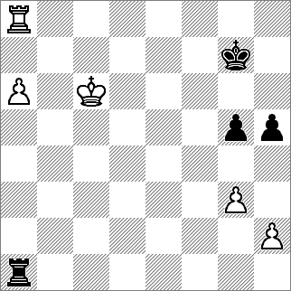
Tarrasch’s Position
White cannot win

By 1. a7, White achieves nothing, for the black Rook remains on the Rook’s (a) file and thereby preventing the white Rook from leaving a8. It is also useless to bring the King to b7 of perpetual checks by the Rook. After 1. a7 there is only one pitfall which black must avoid, namely 1. …Kf2? The consequence of this mistake would be 2. Rh8 and Black lose his Rook if he captures the Pawn!
White, however, might try another plan of winning the game, namely, 1. Kb7 and a7 in order to continue with Rb8 and b6 followed by Kb7 and a7. This might lead to a result typical of this class of Rook ending. White, it is true, may succeed in winning the Rook for the passed Pawn, but in the meantime Black
has the opportunity of also obtaining a passed Pawn and, thus, forcing a draw.
The game might continue as follows:

1.Kb7 Ra2
2.h3 Rh2
3.h4 gxh4
4.gxh4 Rxh4
5.Ka7 Ra4
6.Rb8 Kg6
7.Rb6+ Kg5
8.Kb7 h4
9.a7 h3
10.a8Q Rxa8
11.Kxa8 Kg4
and the student can workout for himself if this is a draw or not.
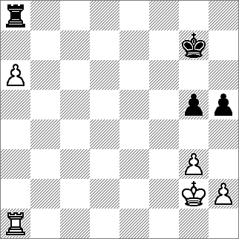
White wins

It can be seen at once that this position is much more favourable for White than the preceding, in spite that his King is further away from the passed Pawn. White can now quietly play a7 threatening to bring his King to b7. Black can only prevent this by bringing his own King to the Queen’s side, but in this case he will lose both his Pawns and thereby the game. For instance:
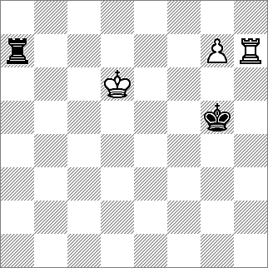
1.a7 Kf6
2.Kf3 Ke5
3.Ke3 Kd5
4.Kd3 h4
5.g4 Ke5
6.Ke3 h3
7.Ra5+ Kf6
8.Ke4

Rook endings quite frequently in apparently clear and very simple positions, contain deeply hidden subtleties, as shown by the two following examples:

Black to move, White wins
Black cannot stop his opponent’s Pawn by Ra8, because of the reply Rh8. Therefore his only move is:

1...Ra6+ 2.Kd5 Rg6 [2...Ra5+? 3.Kc4] 3.Ke5 Kg4 4.Rh1 Kf3 [4...Rxg7 5.Rg1+] 5.Rf1+ Ke2 6.Rf7 Ke3 7.Kf5

Lasker’s Position
White, to move, wins
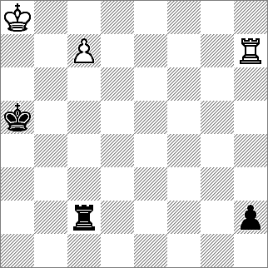
1.Kb7 Rb2+ 8.Ka5 Rc2
2.Ka7 Rc2 9.Rh3+ Ka2
3.Rh5+ Ka4 10.Rxh2
4.Kb7 Rb2+
5.Ka6 Rc2
6.Rh4+ Ka3
7.Kb6 Rb2+ Piet van Zyl

